**Oracle Database Patching**

An Oracle patch is a software update designed to address specific issues, enhance security, improve performance, These patches can be applied to ensure they remain secure, stable, and compatible with evolving technologies.

**Oracle database patching involves several types of patches, each serving specific purposes:**

**Interim Patch**:

* Also known as one-off or single bug fix, these address specific issues and are released between major updates.

**Bundle Patch**:

* These are cumulative patches that include multiple fixes and minor enhancements.

**Security Patch Update (SPU)**:

* Focused on addressing security vulnerabilities, these are released quarterly.

**Patch Set Update (PSU)**:

* These patches address critical bugs and are released quarterly.
* JANUARY, APRIL, JULY, OCTOBER.

**Steps To Apply PATCH:**

* When Patch is applied. Binaries which will be modifed during patch are backedup and stored in hidden directory called **.patch_storage**
* This is located in **ORACLE_HOME**

1. Take TAR backup of ORACLE_HOME & DATABASE

* tar –cvf 19c.tar 19c

1. Download the patch and copy to server from **METALINK** support.oracle.com.

* <https://updates.oracle.com/download/6880880.html>

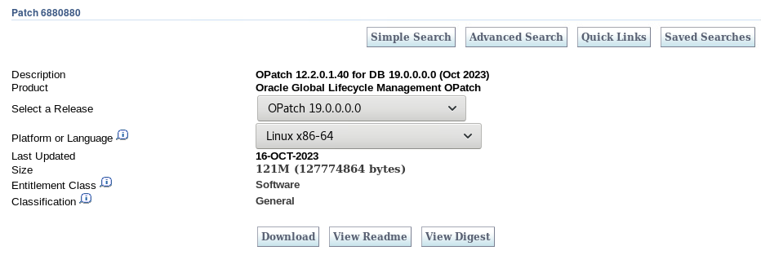

1. Export Opatch path to execute patch commands from any location.

* **export PATH=$ORACLE_HOME/OPatch:$PATH**

1. Check the opatch version

* **./opatch version**
* **OPatch Version: 12.2.0.1.17**
* Applying patch version should be grater then this version.

1. After UNZIP the patch software there is **README.HTML file.**

* this contains the information about **patch version** and steps to apply patch.
* If the new PATCH version is lessthen the existing patch version.
* Copy p6880880_190000_LINUX-x86-64-OPatch-12.2.0.1.36.zip to **ORACLE_HOME** location and unzip. Before unzip take the old **OPatch** directory to backup.
* This will update the OPatch utility version.

1. Check the before applied patch.

* **opatch lsinventory**
* **opatch lspatches**

1. Check the patch conflicts.

* **opatch prereq CheckConflictAgainstOHWithDetail -ph ./**
* This will check any conflicts with the previous patches. If any that should be rollback.

1. Check the invalid objects count.

* select count(*) from DBA_OBJECTS where status='INVALID';

1. Stop all the services running on that home

* **LISTENER**
* **DATABASE**
* **ENTERPRISE MANAGER**
* /sbin/fuser /SSD/oracle/app/oracle/product/19c/dbhome_1/bin/oracle (this shows running services)

1. Go to the patch location an apply patch.

* cd **29585399**
* **opatch apply**

**POST PATCH STEPS:**

1. sqlplus /nolog
2. conn / as sysdba
3. startup
4. alter pluggable database all open;
5. exit
6. cd $ORACLE_HOME/OPatch
7. ./datapatch -verbose

**Datapatch** is a tool introduced in Oracle Database 12c to automate the application of SQL changes after a patch is applied to the database binaries. It ensures that any required updates to the database's data dictionary or metadata are completed, making the patch fully effective.

Here’s how it works:

* After applying a patch using OPatch, you run Datapatch to apply the corresponding SQL changes to the database.
* It updates the database registry to reflect the patch status and ensures consistency across all pluggable databases (PDBs) in a multitenant environment.

Datapatch simplifies the patching process by eliminating the need for manual SQL script execution. If you'd like to explore more, let me know!

**Steps to Rollback Applied Patch:**

* when the patch is **ROLLEDBACK** this will take the information from **.patch_storage** and rollback the patch.

1. Stop all the services running on that oracle home

* **LISTENER**
* **DATABASE**
* **ENTERPRISE MANAGER**
* /sbin/fuser /SSD/oracle/app/oracle/product/19c/dbhome_1/bin/oracle (this shows running services)

1. Check the rollback patch **README.HTML for command and id.**

* **opatch rollback id-** **29585399**

The **local inventory** refers to a repository within the Oracle Home directory that keeps track of the software components installed in that specific Oracle Home. It contains metadata about patches, updates, and configurations applied to that Oracle Home. This is distinct from the **central inventory**, which maintains information about all Oracle Homes on a system.

The local inventory is crucial for managing and troubleshooting Oracle installations, as it helps tools like OPatch verify and apply patches correctly.